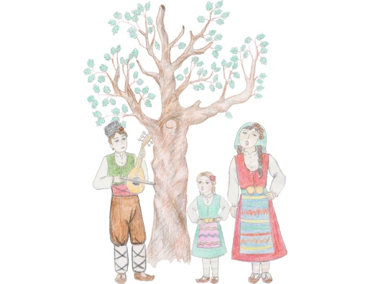 **REGULATIONS**

**INTERNATIONAL FOLKLORE FESTIVAL**

**“MALESHEVO SINGS AND DANCES”-2016**

**MIKREVO VILLAGE**

**21, 22 and 23 October 2016**

**1.Place** where the festival will be held – **the village of Mikrevo**, Municipality of Strumyani, Blagoevgrad region, Bulgaria.

2**. Period** of the Festival – **21, 22 and 23 October 2016** /Friday, Saturday and Sunday/. Every evening – performance of foreign and Bulgarian groups. Gala performance of the winners on Sunday evening.

3. **Participants** in the festival should take part in one of the following age groups:

- younger than 12 years old;

- younger than 18 years old;

- older than 18 years old.

4. **The folklore units** who are able to take part in the contest and **Time limits** for the performances are:

-ensembles, performing folklore songs and dances /up to 20 minutes/;

-folklore dancing ensembles /up to 15 minutes/;

-dancing clubs and schools for traditional Bulgarian dances /up to 8

minutes/;

- vocal groups and choirs, performing folklore songs /up to 6 minutes/;

- instrumental groups, performing folklore music/up to 6 minutes/;

- individual performers, duets and trios/up to 5 minutes/;

- instrumental performers/up to 5 minutes/;

- narrators and rituals /up to 6 minutes/.

5. The Festival has a competitive feature. **The best performers in the Festival program – appointed by the awarding committee are obliged to take part in the official night performances. The evaluation committee has right to stop the performance, if it is longer than the set Time limits.**

6. In the festival program the participants present traditional and arranged folklore. Performers of traditional folklore should keep the local and regional traditional variety of folklore.

7. **Costumes,** requisites and instruments of the groups are of extreme importance in determining authenticity of folklore traditions and manner of living.

8. **The Festival program** is evaluated by a team of experts: folklorists, musicians, choreographers, ethnologists.

**9. Performers and groups are not allowed to present in the Festival program songs and dances, which were presented in former Festival programs.**

10. **Assessment criteria**:

- choice of the repertoire;

- mastery of the performance-style, diction, narrator ability ;

- artistic value of the performance;

- choice of the folklore costumes – structure and function of the

costumes depending on the region;

-it is not recommended to be used “simback” and ”playback”

10.1. **Organizing committee** should appoint the day and order of participating of each ensemble or individual performer who will be informed in advance.

The official program of the Festival will be shown on the official site of Strumyani Municipality minimum 7 days before the beginning of the festival.

10.2. **The organizing committee** has right to change the program, if it is necessary.

11. **Official night performances** will be organized in two parts:

- First part includes participation of the best Bulgarian performers and

ensembles;

- Second part includes the participation of foreign guests - performers

and ensembles.

12. **Groups and individual performers** **should confirm their participation in the Festival before 15th of September 2016.**

**13. All expenses of the participants are for their own accounts.**

**14. Participants do not pay any fee.**

**15. Prizes of the Festival:**

* **Grand Prix “Maleshevo sings and dances” 2016;**
* **Prize of the Mayor of Strumyani Municipality;**
* **Prize “80 years Anniversary”of “Bratya Miladinovi “community center - Mikrevo village /it will be given to a community center/;**
* **Prizes for musical performance of groups and ensembles :**

- Awards for vocal traditional folklore under **12, to 18 and over 18**

**years old – I, II and III place**;

- Awards for vocal revised folklore under **12, to 18 and over 18 years old – І, ІІ and ІІІ place;**

* **Prizes for dance performance:**

- Awards for dance performance – dance groups **under 12,18 and**

**over 18**  **years old –** І, ІІ and ІІІ place;

- Awards for dance performance – ensembles – traditional

Folklore - І, ІІ and ІІІ place;

- Awards for dance performance – ensembles – revised folklore –

І, ІІ and ІІІ place;

• **Awards for dances -** dancing clubs and schools for traditional

Bulgarian dances - І, ІІ and ІІІ place;

* **Awards for musical performance** under **12, 18 and over 18 years –** І, ІІ and ІІІ place.
* **Awards for individual vocal performance under 12, to 18 and over 18 years old –** І, ІІ and ІІІ place.
* **Special awards for a narrator.**
* **Awards for original costume:** І, ІІ and ІІІ place;
* **Prize of BNR - Radio Blagoevgrad – a media partner of the Festival.**
* **All Festival participants will receive a Diploma for participation.**

**16. It is not allowed separation of one unit of sub-folk.**

16.1. The organisation committee shall provide a person in charge for each foreign group for welcoming and logistic support during their stay in Strumyani Municipality for the period of the Festive days .

16.2. Reception and registration desk, upon arrival, is organized in front of the Community center in Mikrevo village.

17. It is recommended /not obligatory/ to be sent via e-mail or by post at Strumyany Municipality address the last album of the artist /group/ or demos not less than two versions. If possible, it is also recommended to be sent annotation and promotional materials like photos,broshures. Submissions will not be returned and authorized their publication to advertise the Festival.

18. Participants provide to IFF “Maleshevo sings and dance” – Mikrevo 2016 copyright and broadcast by radio, TV and DVD recordings of the performances during the Festival.

**19. It is obligatory to be sent an Application form for participation in the Festival.**

**Deadline for Application is till 15.09.2016 on the following address:**

Strumyani Municipality

Strumyani village 2825

Square “7th April” № 1

Blagoevgrad region

**Contacts:**

Fax: +359 07434 / 31-05;   
Telephone: + 359 07434/ 31-08;

Mob:00359 878 428 363;

Bilyana Zlatinova-Chief coordinator of the Festival-mob:00359 885 921 727 ;

E-mail: [maleshevopee@gmail.com](mailto:maleshevopee@gmail.com), [strumyani_oba@yahoo.com](mailto:strumyani_oba@yahoo.com);   
Web: [www.strumyani.org,www.strumyani.eu](http://www.strumyani.org,www.strumyani.eu)